UNIT-4
Implementation:Coding Principles, Coding Process, Code verification, Code documentation,Software Testing: Testing Fundamentals, Test Planning, Black Box Testing, White Box Testing, Levels of Testing, Usability Testing, Regression testing, Debugging approaches.
Testing Fundamentals:
The goal of testing is to find errors, and a good test is one that has a high probability of finding an error. Therefore, you should design and implement a computer based system or a product with “testability” in mind. At the same time, the tests themselves must exhibit a set of characteristics that achieve the goal of finding the most errors with a minimum of effort.
Testability. James Bach1 provides the following definition for testability: “Software testability is simply how easily [a computer program] can be tested.” The following characteristics lead to testable software.
Operability. “The better it works, the more efficiently it can be tested.” If a system is designed and implemented with quality in mind, relatively few bugs will block the execution of tests, allowing testing to progress without fits and starts.
Observability. “What you see is what you test.” Inputs provided as part of testing produce distinct outputs. System states and variables are visible or queriable during execution. Incorrect output is easily identified. Internal errors are automatically
detected and reported. Source code is accessible.
Controllability. “The better we can control the software, the more the testing can be automated and optimized.” All possible outputs can be generated through some combination of input, and I/O formats are consistent and structured. All code is executable through some combination of input. Software and hardware states and variables can be controlled directly by the test engineer. Tests can be conveniently
specified, automated, and reproduced.
Decomposability. “By controlling the scope of testing, we can more quickly isolate problems and perform smarter retesting.” The software system is built from independent modules that can be tested independently.

Simplicity. “The less there is to test, the more quickly we can test it.” The program should exhibit functional simplicity (e.g., the feature set is the minimum necessary to meet requirements); structural simplicity (e.g., architecture is modularized to limit the propagation of faults), and code simplicity (e.g., a coding standard is
adopted for ease of inspection and maintenance).
Stability. “The fewer the changes, the fewer the disruptions to testing.” Changes to the software are infrequent, controlled when they do occur, and do not invalidate existing tests. The software recovers well from failures.
Understandability. “The more information we have, the smarter we will test.” The architectural design and the dependencies between internal, external, and shared components are well understood. Technical documentation is instantly accessible, well organized, specific and detailed, and accurate. Changes to the design are communicated to testers.
Test Characteristics
A good test has a high probability of finding an error. To achieve this goal, the tester must understand the software and attempt to develop a mental picture of how the software might fail. Ideally, the classes of failure are probed. For example, one class of potential failure in a graphical user interface is the failure to recognize proper mouse position. A set of tests would be designed to exercise the mouse in an attempt to demonstrate an error in mouse position recognition.
A good test is not redundant. Testing time and resources are limited. There is no point in conducting a test that has the same purpose as another test. Every test should have a different purpose (even if it is subtly different).
A good test should be “best of breed” [Kan93]. In a group of tests that have a similar intent, time and resource limitations may mitigate toward the execution of only a subset of these tests. In such cases, the test that has the highest likelihood of uncovering a whole class of errors should be used.
A good test should be neither too simple nor too complex. Although it is sometimes possible to combine a series of tests into one test case, the possible side effects associated with this approach may mask errors. In general, each test should be
executed separately.

Test Planning:

A test plan is a document that consists of all future testing-related activities. It is prepared at the project level and in general, it defines work products to be tested, how they will be tested, and test type distribution among the testers. Before starting testing there will be a test manager who will be preparing a test plan. In any company whenever a new project is taken up before the tester involves in the testing the test manager of the team would prepare a test Plan.
The following are some of the key benefits of making a test plan:
- It acts as a quick guide for the testing process.
- It helps to avoid out-of-scope functionalities.
- It determines the time, cost, and effort.
- Provide a schedule for testing activities.
- Resource requirement and equipment.
- Test Plan Document can be used for similar projects.
- It helps to understand the test details.
- It helps in determining the quality of software applications.
Type of Test Plan
The following are the three types of test plans:
- Master Test Plan- In this type of test plan, includes multiple test strategies and has multiple levels of testing.
- Phase Test Plan- In this type of test plan, emphasis on any one phase of testing.
- Specific Test Plan- In this type of test plan, it is designed for specific types of testing especially non-functional testing.
BLACK BOX TESTING:
In black-box testing, test cases are designed from an examination of the input/output values only and no knowledge of design or code is required. The following are the two main approaches available to design black box test cases:
- • Equivalence class partitioning
- • Boundary value analysis

Equivalence Class Partitioning
In the equivalence class partitioning approach, the domain of input values to the program under test is partitioned into a set of equivalence classes. The partitioning is done such that for every input data belonging to the same equivalence class, the program behaves similarly.
Equivalence classes for a unit under test can be designed by examining the input data and output data. The following are two general guidelines for designing the equivalence classes:
1. If the input data values to a system can be specified by a range of values, then one valid and two invalid equivalence classes need to be defined. For example, if the equivalence class is the set of integers in the range 1 to 10 (i.e., [1,10]), then the invalid equivalence classes are [−∞,0], [11,+∞].
2. If the input data assumes values from a set of discrete members of some domain, then one equivalence class for the valid input values and another equivalence class for the invalid input values should be defined.
Ex : For a software that computes the square root of an input integer that can assume values in the range of 0 and 5000. Determine the equivalence classes and the black box test suite.
Answer: There are three equivalence classes—The set of negative integers, the set of integers in the range of 0 and 5000, and the set of integers larger than 5000. Therefore, the test cases must include representatives for each of the three equivalence classes.
A possible test suite can be: {–5,500,6000}
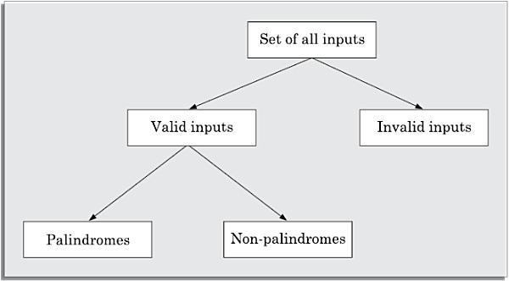

Boundary Value Analysis
Boundary value analysis-based test suite design involves designing test cases using the values at the boundaries of different equivalence classes.
To design boundary value test cases, it is required to examine the equivalence classes to check if any of the equivalence classes contains a range of values. For those equivalence classes that are not a range of values no boundary value test cases can be defined. For an equivalence class that is a range of values, the boundary values need to be included in the test suite.
For example, if an equivalence class contains the integers in the range 1 to 10, then the boundary value test suite is {0,1,10,11}.
Ex : For a function that computes the square root of the integer values in the range of 0 and 5000, determine the boundary value test suite.
Answer: There are three equivalence classes—The set of negative integers, the set of integers in the range of 0 and 5000, and the set of integers larger than 5000. The boundary value-based test
suite is: {0,-1,5000,5001}.
WHITE-BOX TESTING
White-box testing is an important type of unit testing. A large number of white-box testing strategies exist. Each testing strategy essentially designs test cases based on analysis of some aspect of source code and is based on some heuristic.
A white-box testing strategy can either be coverage-based or fault-based.
Fault-based testing A fault-based testing strategy targets to detect certain types of faults. These faults that a test strategy focuses on constitutes the fault model of the strategy.
Coverage-based testing
A coverage-based testing strategy attempts to execute (or cover) certain elements of a program. Popular examples of coverage-based testing strategies are statement coverage, branch coverage, multiple condition coverage, and path coverage-based testing.
A coverage-based testing strategy typically targets to execute (i.e., cover) certain program elements for discovering failures.

Stronger versus weaker testing
A white-box test In the weaker strategy. When none of two testing strategies fully covers the program elements exercised by g strategy is said to be stronger than another strategy, if the stronger testing strategy covers all program elements covered by the weaker testing strategy, and the stronger strategy additionally covers at least one program element that is not covered by the other, then the two are called complementary testing strategies.
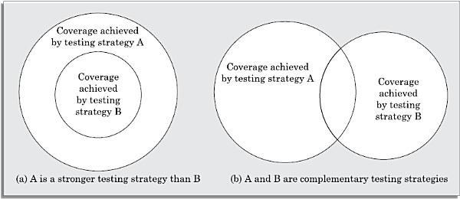
Figure : Illustration of stronger, weaker, and complementary testing strategies.

The statement coverage strategy aims to design test cases so as to execute every statement in a program at least once.
Branch Coverage
A test suite satisfies branch coverage, if it makes each branch condition in the program to assume true and false values in turn. In other words, for branch coverage each branch in the CFG representation of the program must be taken at least once, when the test suite is executed. Branch testing is also known as edge testing, since in this testing scheme, each edge of a program’s control flow graph is traversed at least once.
Multiple Condition Coverage
In the multiple condition (MC) coverage-based testing, test cases are designed to make each component of a composite conditional expression to assume both true and false values.
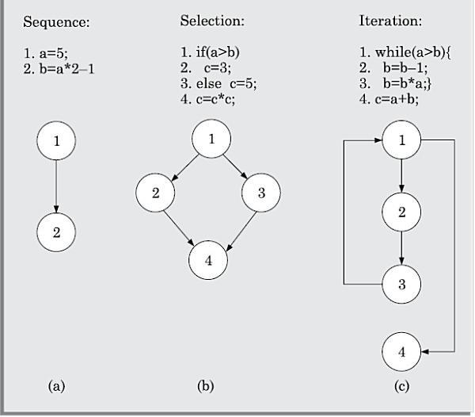
Figure : (a) sequence, (b) selection, and (c) iteration type of constructs

Path Coverage
A test suite achieves path coverage if it executes each linearly independent paths (or basis paths) at least once. A linearly independent path can be defined in terms of the control flow graph (CFG) of a program.
Control flow graph (CFG)
A control flow graph describes the sequence in which the different instructions of a program get executed. In order to draw the control flow graph of a program, we need to first number all the statements of a program. The different numbered statements serve as nodes of the control flow graph. There exists an edge from one node to another, if the execution of the statement representing the first node can result in the transfer of control to the other node.
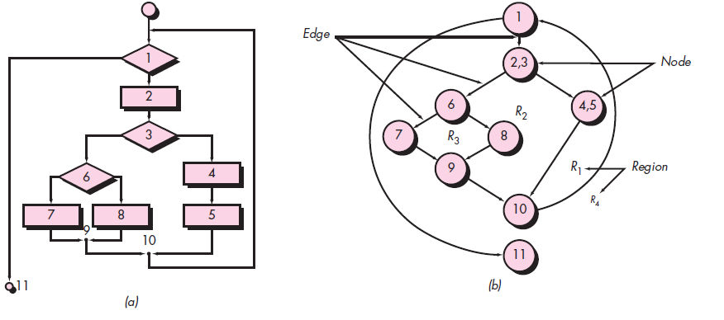

Path
A path through a program is any node and edge sequence from the start node to a terminal node of the control flow graph of a program. Please note that a program can have more than one terminal nodes when it contains multiple exit or return type of statements. Writing test cases to cover all paths of a typical program is impractical since there can be an infinite number of paths through a program in presence of loops.
An independent path is any path through the program that introduces at least one new set of processing statements or a new condition. When stated in terms of a flow graph, an independent path must move along at least one edge that has not been traversed before the path is defined.
For example, a set of independent paths for the flow graph illustrated in figure (b) is
Path 1: 1-11
Path 2: 1-2-3-4-5-10-1-11
Path 3: 1-2-3-6-8-9-10-1-11
Path 4: 1-2-3-6-7-9-10-1-11
Note that each new path introduces a new edge. The path
1-2-3-4-5-10-1-2-3-6-8-9-10-1-11 is not considered to be an independent path because it is simply a combination of already specified paths and does not traverse any new edges.
How do you know how many paths to look for? The computation of cyclomatic complexity provides the answer.
Cyclomatic complexity is a software metric that provides a quantitative measure of the logical complexity of a program. When used in the context of the basis p th testing method, the value computed for cyclomatic complexity defines the number of
independent paths in the basis set of a program and provides you with an upper bound for the number of tests that must be conducted to ensure that all statements have been executed at least once.
Cyclomatic complexity has a foundation in graph theory and provides you with an extremely useful software metric. Complexity is computed in one of three ways:
1. The number of regions of the flow graph corresponds to the cyclomatic complexity.
2. Cyclomatic complexity V(G) for a flow graph G is defined as
V(G) = E – N+ 2 ;
where E is the number of flow graph edges and N is the number of flow graph nodes.
3. Cyclomatic complexity V(G) for a flow graph G is also defined as
V(G) = P+1
where P is the number of predicate nodes contained in the flow graph G.
Referring once more to the flow graph in figure (b), the cyclomatic complexity can be computed using each of the algorithms just noted:
1. The flow graph has four regions.
2. V(G) = 11 edges - 9 nodes + 2 = 4.
3. V(G) = 3 predicate nodes + 1 = 4.
Therefore, the cyclomatic complexity of the flow graph in figure (b) is 4.
Levels of Testing:
In Software Engineering, four main levels of testing are Unit Testing, Integration Testing, System Testing and Acceptance Testing.
UNIT TESTING:
Unit testing focuses verification effort on the smallest unit of software design—the software component or module. Using the component-level design description as a guide, important control paths are tested to uncover errors within the boundary of the module. The relative complexity of tests and uncovered errors is limited by the constrained scope established for unit testing. The unit test is white-box oriented, and the step can be conducted in parallel for multiple components.
Driver and stub modules
In order to test a single module, we need a complete environment to provide all relevant code that is necessary for execution of the module. That is, besides the module under test, the following are needed to test the module:
The procedures belonging to other modules that the module under test calls• Non-local data structures that the module accesses.
A procedure to call the functions of the module under test with appropriate parameters.
Modules required to provide the necessary environment (which either call or are called by the module under test) are usually not available until they too have been unit tested.
Stub: The role of stub and driver modules is pictorially shown in following figure. A stub procedure is a dummy procedure that has the same I/O parameters as the function called by the unit under test but has a highly simplified behaviour.

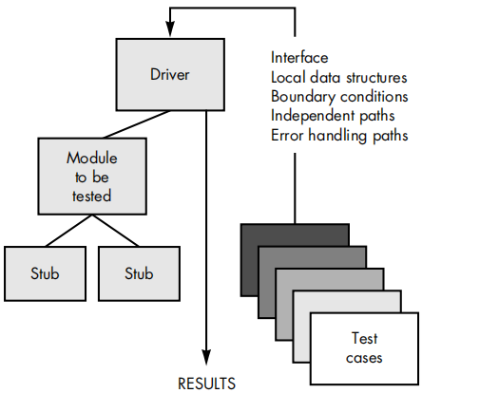

Driver: A driver module should contain the non-local data structures accessed by the module under test. Additionally, it should also have the code to call the different functions of the unit under test with appropriate parameter values for testing.
Unit Test Procedures:
Unit testing is normally considered as an adjunct to the coding step. After source level code has been developed, reviewed, and verified for correspondence to componentlevel design, unit test case design begins. A review of design information provides guidance for establishing test cases that are likely to uncover errors in each of the categories discussed earlier. Each test case should be coupled with a set of expected results.
INTEGRATION TESTING
Integration testing is carried out after all (or at least some of ) the modules have been unit tested. Successful completion of unit testing, to a large extent, ensures that the unit (or module) as a whole works satisfactorily. In this context, the objective of integration testing is to detect the errors at the module interfaces (call parameters).
The primary objective of integration testing is to test the module interfaces, i.e., there are no errors in parameter passing, when one module invokes the functionality of another module.
During integration testing, different modules of a system are integrated in a planned manner using an integration plan.
The integration plan specifies the steps and the order in which modules are combined to realize the full system. After each integration step, the partially integrated system is tested.
An important factor that guides the integration plan is the module dependency graph. By examining the structure chart, the integration plan can be developed. Any one (or a mixture) of the following approaches can be used to develop the test plan:
- ✓Big-bang approach to integration testing
- ✓Top-down approach to integration testing
- ✓Bottom-up approach to integration testing
- ✓Mixed (also called sandwiched ) approach to integration testing
Big-bang approach to integration testing:✓
Big-bang testing is the most obvious approach to integration testing. In this approach, all the modules making up a system are integrated in a single step.
In simple words, all the unit tested modules of the system are simply linked together and tested. However, this technique can meaningfully be used only for very small systems. The main problem with this approach is that once a failure has been detected during integration testing, it is very difficult to localise the error as the error may potentially lie in any of the modules.
Therefore, debugging errors reported during big-bang integration testing are very expensive to fix. As a result, big-bang integration testing is almost never used for large programs.
Bottom-up approach to integration testing
In bottom-up integration testing, first the modules for the each subsystem are integrated. Thus, the subsystems can be integrated separately and independently.The primary purpose of carrying out the integration testing a subsystem is to test whether the interfaces among various modules making up the subsystem work satisfactorily. The test cases must be carefully chosen to exercise the interfaces in all possible manners.
In a pure bottom-up testing no stubs are required, and only test-drivers are required. Large software systems normally require several levels of subsystem testing, lower-level subsystems are successively combined to form higher-level subsystems.
The principal advantage of bottom up integration testing is that several disjoint subsystems can be tested simultaneously. Another advantage of bottom-up testing is that the low-level modules get tested thoroughly, since they are exercised in each integration step. Since the low-level modules do I/O and other critical functions, testing the low-level modules thoroughly increases the reliability of the system.
A disadvantage of bottom-up testing is the complexity that occurs when the system is made up of a large number of small subsystems that are at the same level.
Top-down approach to integration testing
Top-down integration testing starts with the root module in the structure chart and one or two subordinate modules of the root module. After the top-level ‘skeleton’ has been tested, the modules that are at the immediately lower layer of the ‘skeleton’ are combined with it and tested.
Top-down integration testing approach requires the use of program stubs to simulate the effect of lower-level routines that are called by the routines under test. A pure top-down integration does not require any driver routines.
An advantage of top-down integration testing is that it requires writing only stubs, and stubs are simpler to write compared to drivers. A disadvantage of the top-down integration testing
approach is that in the absence of lower-level routines, it becomes difficult to exercise the toplevel routines in the desired manner since the lower level routines usually perform input/output (I/O) operations.
Mixed approach to integration testing
The mixed (also called sandwiched ) integration testing follows a combination of top-down and bottom-up testing approaches. In top-down approach, testing can start only after the toplevel modules have been coded and unit tested. Similarly, bottom-up testing can start only after the bottom level modules are ready.
The mixed approach overcomes this shortcoming of the topdown and bottom-up approaches. In the mixed testing approach, testing can start as and when modules become available after unit testing. Therefore, this is one of the most commonly used integration testing approaches. In this approach, both stubs and drivers are required to be designed.

SYSTEM TESTING
System tests are designed to validate a fully developed system to assure that it meets its requirements. The test cases are therefore designed solely based on the SRS document.
There are essentially three main kinds of system testing depending on who carries out testing:
1. Alpha Testing: Alpha testing refers to the system testing carried out by the test team within the developing organization.
2. Beta Testing: Beta testing is the system testing performed by a select group of friendly customers.
3. Acceptance Testing: Acceptance testing is the system testing performed by the customer to determine whether to accept the delivery of the system.Before a fully integrated system is accepted for system testing, smoke testing is performed.
Smoke testing is done to check whether at least the main functionalities of the software are working properly. Unless the software is stable and at least the main functionalities are working satisfactorily, system testing is not undertaken.
The performance tests, on the other hand, test the conformance of the system with the non-functional requirements of the system.
Smoke Testing
Smoke testing is carried out before initiating system testing to ensure that system testing would be meaningful, or whether many parts of the software would fail. The idea behind smoke testing is that if the integrated program cannot pass even the basic tests, it is not ready for a vigorous testing.
For smoke testing, a few test cases are designed to check whether the basic functionalities are working. For example, for a library automation system, the smoke tests may check whether books can be created and deleted, whether member records can be created and deleted,, and whether books can be loaned and returned.
Performance Testing
Performance testing is an important type of system testing. Performance testing is carried out to check whether the system meets the non-functional requirements identified in the SRS document. All performance tests can be considered as black-box tests. The following are different performance testing techniques.

Stress testing
Stress testing is also known as endurance testing. Stress testing evaluates system performance when it is stressed for short periods of time. Stress tests are black-box tests which are designed to impose a range of abnormal and even illegal input conditions so as to stress the capabilities of the software.
Stress testing is especially important for systems that under normal circumstances operate below their maximum capacity but may be severely stressed at some peak demand hours.
Volume testing
Volume testing checks whether the data structures (buffers, arrays, queues, stacks, etc.) have been designed to successfully handle extraordinary situations.
Configuration testing
Configuration testing is used to test system behavior in various hardware and software configurations specified in the requirements. Sometimes systems are built to work in different configurations for different users. For instance, a minimal system might be required to serve a single user, and other extended configurations may be required to serve additional users during configuration testing.
The system is configured in each of the required configurations and depending on the specific customer requirements, it is checked if the system behaves correctly in all required configurations.
Compatibility testing
This type of testing is required when the system interfaces with external systems (e.g., databases, servers, etc.). Compatibility aims to check whether the interfaces with the external systems are performing as required.
Regression testing
This type of testing is required when a software is maintained to fix some bugs or enhance functionality, performance, etc.
Recovery testing
Recovery testing tests the response of the system to the presence of faults, or loss of power, devices, services, data, etc. The system is subjected to the loss of the mentioned resources and it is checked if the system recovers satisfactorily

ACCEPTANCE TESTING:
Acceptance testing is a test conducted to find if the requirements of a specification or contract are met as per its delivery. Acceptance testing is basically done by the user or customer. However, other stockholders can be involved in this process.
Types of Acceptance Testing:
User Acceptance Testing (UAT): User acceptance testing is used to determine whether the product is working for the user correctly. Specific requirements which are quite often used by the customers are primarily picked for the testing purpose. This is also termed as End-User Testing.
Business Acceptance Testing (BAT): BAT is used to determine whether the product meets the business goals and purposes or not. BAT mainly focuses on business profits which are quite challenging due to the changing market conditions and new technologies so the current implementation may have to being changed which results in extra budgets.
Contract Acceptance Testing (CAT): CAT is a contract that specifies that once the product goes live, within a predetermined period, the acceptance test must be performed and it should pass all the acceptance use cases. Here is a contract termed a Service Level Agreement (SLA), which includes the terms where the payment will be made only if the Product services are in-line with all the requirements, which means the contract is fulfilled. Sometimes, this contract happens before the product goes live. There should be a well-defined contract in terms of the period of testing, areas of testing, conditions on issues encountered at later stages, payments, etc.
Regulations Acceptance Testing (RAT): RAT is used to determine whether the product violates the rules and regulations that are defined by the government of the country where it is being released. This may be unintentional but will impact negatively on the business.
Alpha Testing: Alpha testing is used to determine the product in the development testing environment by a specialized testers team usually called alpha testers.
Beta Testing: Beta testing is used to assess the product by exposing it to the real end-users, usually called beta testers in their environment. Feedback is collected from the users and the defects are fixed. Also, this helps in enhancing the product to give a rich user experience.

Regression testing :
Regression testing spans unit, integration, and system testing. Instead, it is a separate dimension to these three forms of testing. Regression testing is the practice of running an old test suite after each change to the system or after each bug fix to ensure that no new bug has been introduced due to the change or the bug fix. Whenever a software is changed to either fix a bug, or enhance or remove a feature, regression testing is carried out
Regression testing may be conducted manually, by re-executing a subset of all test cases or using automated capture/playback tools. Capture/playback tools enable the software engineer to capture test cases and results for subsequent playback and comparison.
The regression test suite (the subset of tests to be executed) contains three different classes of test cases:
• A representative sample of tests that will exercise all software functions.
• Additional tests that focus on software functions that are likely to be affected by the change.
• Tests that focus on the software components that have been changed.
As integration testing proceeds, the number of regression tests can grow quite large.Therefore, the regression test suite should be designed to include only those tests
that address one or more classes of errors in each of the major program functions. It is impractical and inefficient to re-execute every test for every program function once
a change has occurred.
DEBUGGING
Debugging is the process of fixing a bug in the software. In other words, it refers to identifying, analyzing, and removing errors. This activity begins after the software fails to execute properly and concludes by solving the problem and successfully testing the software. It is considered to be an extremely complex and tedious task because errors need to be resolved at all stages of debugging.
Debugging Approaches
The following are some of the approaches that are popularly adopted by the programmers for debugging:

Brute force method
This is the most common method of debugging but is the least efficient method. In this approach, print statements are inserted throughout the program to print the intermediate values with the hope that some of the printed values will help to identify the statement in error.
This approach becomes more systematic with the use of a symbolic debugger (also called a source code debugger), because values of different variables can be easily checked and break points and watch points can be easily set to test the values of variables effortlessly.
Single stepping using a symbolic debugger is another form of this approach, where the developer mentally computes the expected result after every source instruction and checks whether the same is computed by single stepping through the program.
Backtracking
This is also a fairly common approach. In this approach, starting from the statement at which an Error symptom has been observed, the source code is traced backwards until the error is discovered. Unfortunately, as the number of source lines to be traced back increases, the number of potential backward paths increases and may become unmanageable large for complex programs, limiting the use of this approach.
Cause elimination method
In this approach, once a failure is observed, the symptoms of the failure (i.e., certain variable is having a negative value though it should be positive, etc.) are noted. Based on the failure symptoms, the causes which could possibly have contributed to the symptom are developed and tests are conducted to eliminate each. A related technique of identification of the error from the error symptom is the software fault tree analysis.
Program slicing
This technique is similar to back tracking. In the backtracking approach, one often has to examine a large number of statements. However, the search space is reduced by defining slices.

A slice of a program for a particular variable and at a particular statement is the set of source lines preceding this statement that can influence the value of that variable. Program slicing makes use of the fact that an error in the value of a variable can be caused by the statements on which it is data dependent.
Each of these debugging approaches can be supplemented with debugging tools.We can apply a wide variety of debugging compilers, dynamic debugging aids ("tracers"), automatic test case generators, memory dumps, and cross-reference maps.
However, tools are not a substitute for careful evaluation based on a complete software design document and clear source code.
Debugging Guidelines
Debugging is often carried out by programmers based on their ingenuity and experience. The following are some general guidelines for effective debugging:
- • Many times debugging requires a thorough understanding of the program design. Trying to debug based on a partial understanding of the program design may require an inordinate amount of effort to be put into debugging even for simple problems.
- • Debugging may sometimes even require full redesign of the system. In such cases, a common mistakes that novice programmers often make is attempting not to fix the error but its symptoms.
- • One must be beware of the possibility that an error correction may introduce new errors. Therefore after every round of error-fixing, regression testing must be carried out.
Usability Testing :Usability Testing in software testing is a type of testing, that is done from an end user’s perspective to determine if the system is easily usable. Usability testing is generally the practice of testing how to easy a design is to use on a group of representative users.
A very common mistake in usability testing is conducting a study too late in the design process If you wait until right before your product is released, you won’t have the time or money to fix any issues – and you’ll have wasted a lot of effort developing your product the wrong way.
Phases of Usability Testing
There are five phases in usability testing which are followed by the system when usability testing is performed. These are given below:
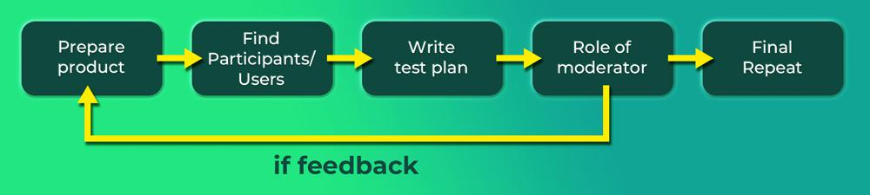

Prepare your product or design to test: The first phase of usability testing is choosing a product and then making it ready for usability testing. For usability testing, more functions and operations are required than this phase provided that type of requirement. Hence this is one of the most important phases in usability testing.
Find your participants: The second phase of usability testing is finding an employee who is helping you with performing usability testing. Generally, the number of participants that you need is based on a number of case studies. Generally, five participants are able to find almost as many usability problems as you’d find using many more test participants.
Write a test plan: This is the third phase of usability testing. The plan is one of the first steps in each round of usability testing is to develop a plan for the test. The main purpose of the plan is to document what you are going to do, how you are going to conduct the test, what metrics you are going to find, the number of participants you are going to test, and what scenarios you will use.
Take on the role of the moderator: This is the fourth phase of usability testing and here the moderator plays a vital role that involves building a partnership with the participant. Most of the research findings are derived by observing the participant’s actions and gathering verbal feedback to be an effective moderator, you need to be able to make instant decisions while simultaneously overseeing various aspects of the research session.
Present your findings/ final report: This phase generally involves combining your results into an overall score and presenting it meaningfully to your audience. An easy method to do this is to compare each data point to a target goal and represent this as one single metric based on a percentage of users who achieved this goal.

Coding:
Coding is a process of establishing a successful communication between a software program and the computer hardware.
Coding Principles:
The principles that guide the coding task are closely aligned with programming style, programming languages, and programming methods.However, there are a number of fundamental principles that can be stated
Preparation principles: Before you write one line of code, be sure you
• Understand of the problem you’re trying to solve.
• Understand basic design principles and concepts.
• Pick a programming language that meets the needs of the software to be built and the environment in which it will operate.
• Select a programming environment that provides tools that will make your work easier.
• Create a set of unit tests that will be applied once the component you code is completed.
Programming principles: As you begin writing code, be sure you
• Constrain your algorithms by following structured programming practice.
• Consider the use of pair programming.
• Select data structures that will meet the needs of the design.
• Understand the software architecture and create interfaces that are consistent with it.
• Keep conditional logic as simple as possible.
• Create nested loops in a way that makes them easily testable.
• Select meaningful variable names and follow other local coding standards.
Write code that is self-documenting.
• Create a visual layout (e.g., indentation and blank lines) that aids understanding.
Validation Principles: After you’ve completed your first coding pass, be sure you
• Conduct a code walk through when appropriate.
• Perform unit tests and correct errors you’ve uncovered.
• Refactor the code.

Coding verification:
Code verification is the process used for checking the software code for errors introduced in the coding phase.
The objective of code verification process is to check the software code in all aspects. This process includes checking the consistency of user requirements with the design phase.
The code verification techniques are classified into two categories, namely, dynamic and static. The dynamic technique is performed by executing some test data. The outputs of the program are tested to find errors in the software code. This technique follows the conventional approach for testing the software code.
In the static technique, the program is executed conceptually and without any data. In other words, the static technique does not use any traditional approach as used in the dynamic technique. Some of the commonly used static techniques are code reading, static analysis, symbolic execution, and code inspection and reviews.
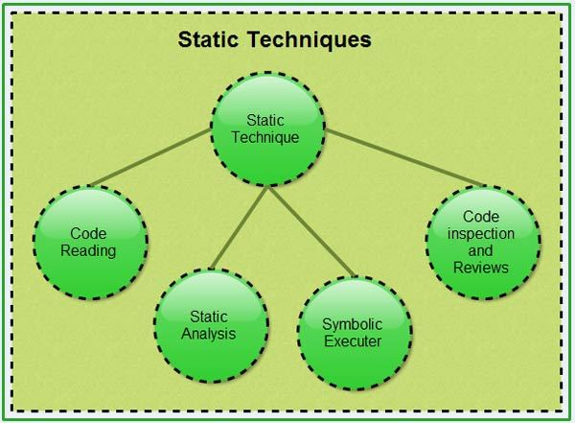

Code Reading:
Code reading is a technique that concentrates on how to read and understand a computer program. It is essential for a software developer to know code reading. The process of reading a software program in order to understand it is known as code reading or program reading. In this process, attempts are made to understand the documents, software specifications, or software designs. The purpose of reading programs is to determine the correctness and consistency of the code.
Static Analysis
Static analysis comprises a set of methods used to analyze the source code or object code of the software to understand how the software functions and to set up criteria to check its correctness.
Static analysis studies the source code without executing it and gives information about the structure of model used, data and control flows, syntactical accuracy, and much more.
Control flow analysis:
This examines the control structures (sequence, selection, and repetition) used in the code. It identifies incorrect and inefficient constructs and also reports unreachable code, that is, the code to which the control never reaches.
Data analysis:
This ensures that-proper operations are applied to data objects (for example, data structures and linked lists). In addition, this method also ensures that the defined data is properly used. Data analysis comprises two methods, namely, data dependency and data-flow analysis.
Fault/failure analysis:
This analyzes the fault (incorrect model component) and failure (incorrect behaviour of a model component) in the model. This method uses input-output transformation descriptions to identify the conditions that are the cause for the failure.
Symbolic Execution
Symbolic execution concentrates on assessing the accuracy of the model by using symbolic values instead of actual data values for input. Symbolic execution, also known as symbolic evaluation, is performed by providing symbolic inputs, which produce expressions for the output.
Symbolic execution uses a standard mathematical technique for representing the arbitrary program inputs (variables) in the form of symbols. To perform the calculation, a machine is employed to perform algebraic manipulation on the symbolic expressions.
Code Inspection and Reviews
This technique is a formal and systematic examination of the source code to detect errors. During this process, the software is presented to the project managers and the users for a comment of approval. Before providing any comment, the inspection team checks the source code for errors. Generally, this team consists of the following.
Moderator: Conducts inspection meetings, checks errors-, and ensures that the inspection process is followed.
Reader: Paraphrases the operation of the software code.
Recorder: Keeps record of each error in the software code. This frees the task of other team members to think deeply about the software code.
Author: Observes the code inspection process silently and helps only when explicitly required. The role of the author is to understand the errors found in the software code.
Code Documentation:
Documentation When various kinds of software products are developed then not only the executable files and the source code are developed but also various kinds of documents such as users’ manual, software requirements specification (SRS) documents, design documents, test documents, installation manual, etc are also developed as part of any software engineering process.
All these documents are a vital part of good software development practice. Good documents are very useful and server the following purposes:
• Good documents enhance understandability and maintainability of a software product.
They reduce the effort and time required for maintenance.
• Use documents help the users in effectively using the system.
• Good documents help in effectively handling the manpower turnover problem. Even when an engineer leaves the organization, and a new engineer comes in, he can build up the required knowledge easily.
• Production of good documents helps the manager in effectively tracking the progress of the project. The project manager knows that measurable progress is achieved if a piece of work is done and the required documents have been produced and reviewed. Different types of software documents can broadly be classified into the following:
• Internal documentation
• External documentation
Internal documentation is the code comprehension features provided as part of the source code itself. Internal documentation is provided through appropriate module headers and comments embedded in the source code.
Internal documentation is also provided through the useful variable names, module and function headers, code indentation, code structuring, use of enumerated types and constant identifiers, use of user-defined data types, etc.
Careful experiments suggest that out of all types of internal documentation meaningful variable names is most useful in understanding the code. This is of course in contrast to the common expectation that code commenting would be the most useful. The research finding is obviously true when comments are written without thought. For example, the following style of code commenting does not in any way help in understanding the code.
a = 10; /* a made 10 */
But even when code is carefully commented, meaningful variable names still are more helpful in understanding a piece of code. Good software development organizations usually ensure good internal documentation by appropriately formulating their coding standards and coding guidelines.
External documentation is provided through various types of supporting documents such as users’ manual, software requirements specification document, design document, test documents, etc. A systematic software development style ensures that all these documents are produced in an orderly fashion.
Coding Process:
- Usally modules are assigned to programmers for coding
- In top-down development, top level modules are developed first; in bottom-up lower levels modules.
- For coding,developer use different process
An Incremental Coding Process :
Basic Process:Write code for the module, unit test it, fix the bugs.it is better to do this incrementally - write code for part of functionality, then test it and fix it, then proceed.
Test Driven Development:
This coding process changes the order of activities in coding.
- In tdd the programmer first write the test scripts and then writes the code to pass the test case in the script.this is done by incrementally is a relatively new approach,and is a part of the extreme programming (XP).
- In TDD you write just enough code to pass the test.I.e code is always in sync with the test and gets tested by the test cases.
- Not true in code first approach,as test cases may only test part of functionality.
- Responsibility to ensure that all functionality is there is on test case design, not coding.
- Help ensure that all code is testable Focus shifts to how code will be used as test cases are written first.
- Helps validate user interfaces specified in the design.
- Has possibility that special cases for which test cases are not possible get left out
- Code improvement through refactoring will be needed to avoid getting a messy code
Pair Programming:
- Also coding process has been proposed as key practice in XP.
- Code is written by pair of programmers rather than individuals
- The pair together design algorithms data structures, strategies…
- One person types the code,the other actively reviews what is being typed
- Errors are pointed out together solutions are formulated.
- Roles are reversed periodically.
PP has continuous code review, and reviews are known to be effective
- Better designs of algorithms,data structures.
- Special conditions are likely to be dealt with better and not forgotten.
- It may,however,results in loss of productivity.
- Ownership and accountability issues are also there.
- Effective is not yet fully known.
Managing Evolving Code:
During coding process, code written by a programmer evolves. Code by different programmers have to be put together to form the system. Besides normal code changes, requirement changes also cause change. Evolving code has to be managed.
Source Code Control and Built:

Source code control is an essential step programmers have to do Generally tools like CVS, VSS are used. A tool consists of repository, which is a controlled directory structure. The repository is the official source for all the code files. System build is done from the files in the repository only. Tool typically provides many commands to programmers.
    - Checkout a file: by this a programmer gets a local copy that can be modified.
    - Check in a file: changed files are uploaded in the repository and change is then available to all.
    - Tools maintain complete change history andν all older versions can be recovered.

    - Source code control is an essential tool forν developing large projects and for coordination.
Refactoring:
Refactoring is a technique to improve existing code by improving its design (i.e. the internal structure).In TDD, refactoring is a key step. Refactoring is done generally to recue coupling or increase cohesion. Involves changing of code to improve some design property. No new functionality is added. To mitigate risks associated with refactoring two golden rules.
Refactor in small steps. Have test scripts available to test that the functionality is preserved. With refactoring code is continually improving; refactoring cost is paid by reduced main effort later. There are various refactoring patternsν that have been proposed.

“Bad smells” that suggest that refactoring may be desired

  - Duplicate code
  - Long method
  - Long class
  - Long parameter list
  - Switch statement
  - Speculative generality
- •Too much communication between objects, etc

